Findings | Screenshots
Font should Arial.  During Searching the button should Last Name, First Name | 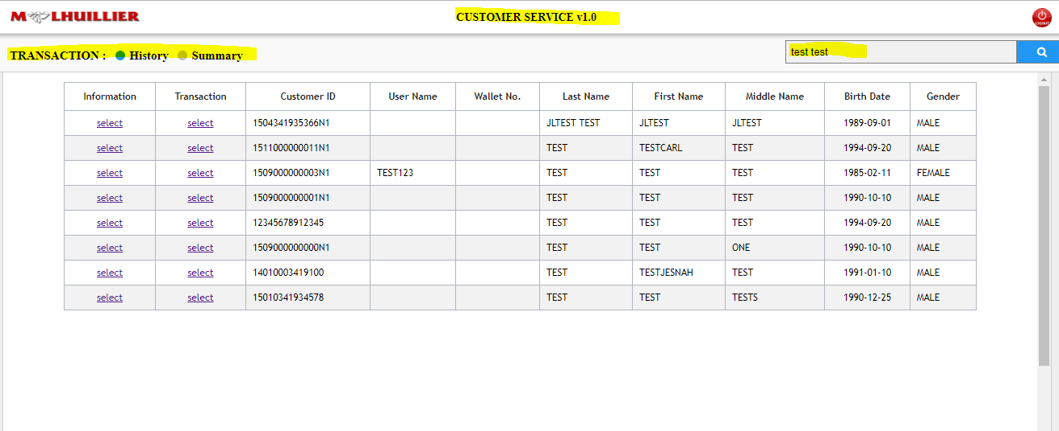
Wrong Spelling for CUSTOMER id | 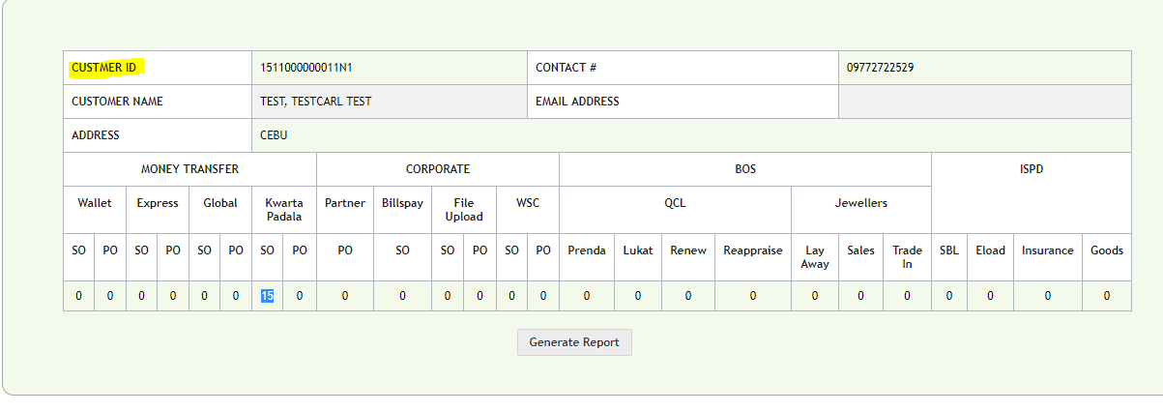
Add Last Name and First Name during searching in Summary. | 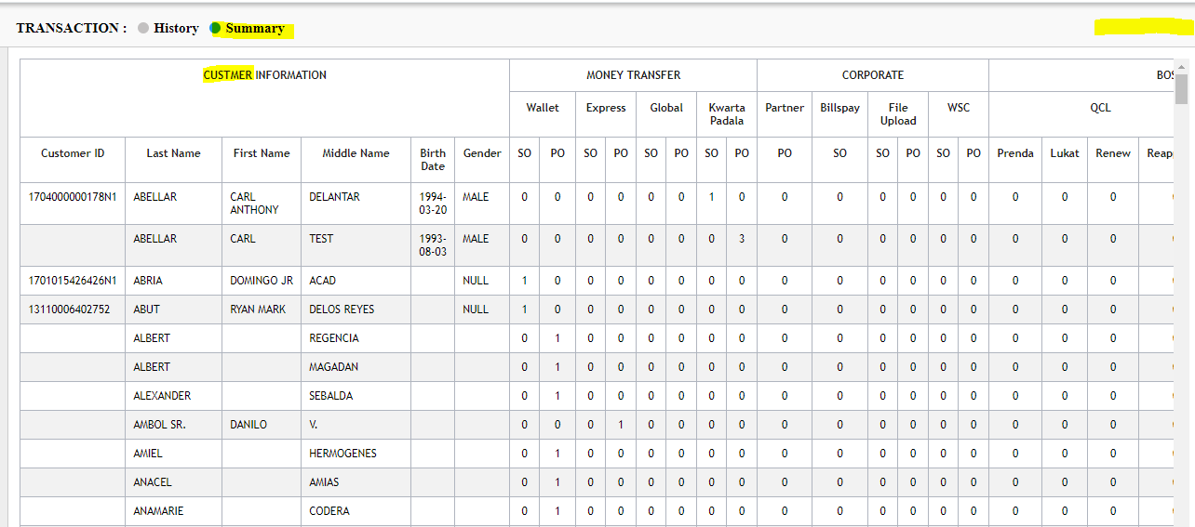
Format for Form:  Remove ZONE  - Transaction Type  - Transaction Date  - KPTN  - Principal  - Charge  - Sender Name  - Receiver Name  - SO Branch  - PO Branch | 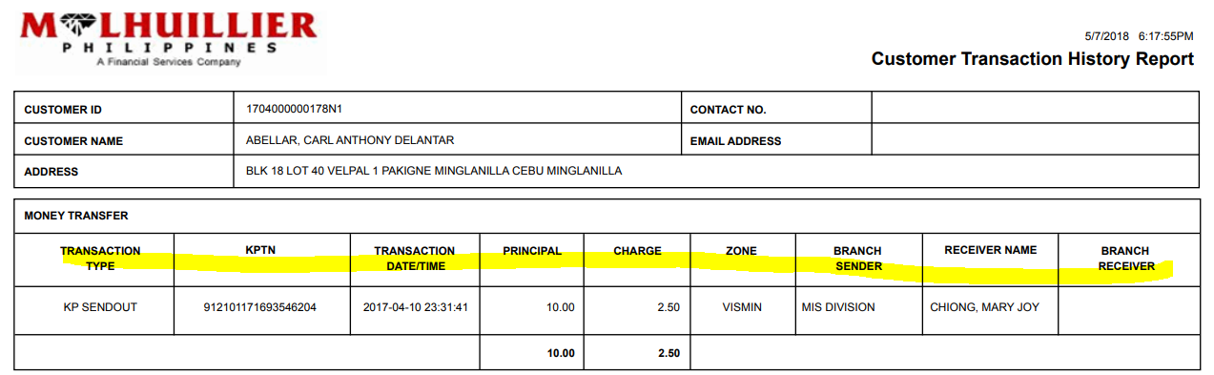
Wrong spelling for CUSTOMER ID and Middle Name.  - Add Picture. | 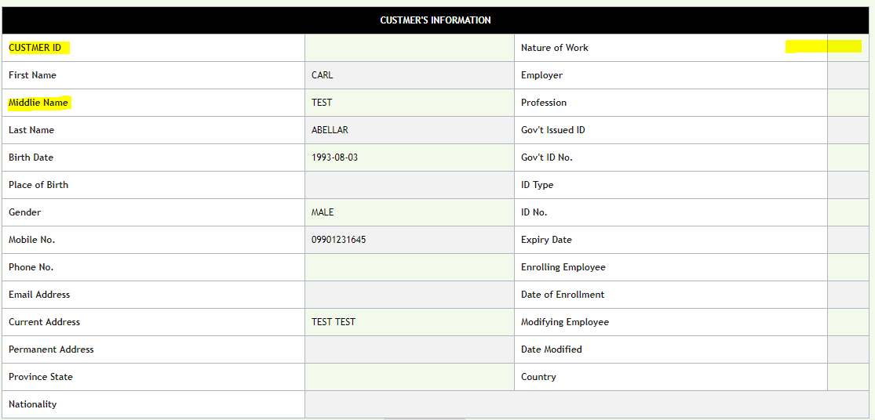
- Add photo  - Delete Remarks | 